Procedural report (project phase I)

Name: Abdulwahab Hassan Alzahrani

ID: 201337310

Abstract

This report shows the procedural process of establishing the connection and communication between the client as one party of the communicators and the server side which is considered as the second party of the communication.

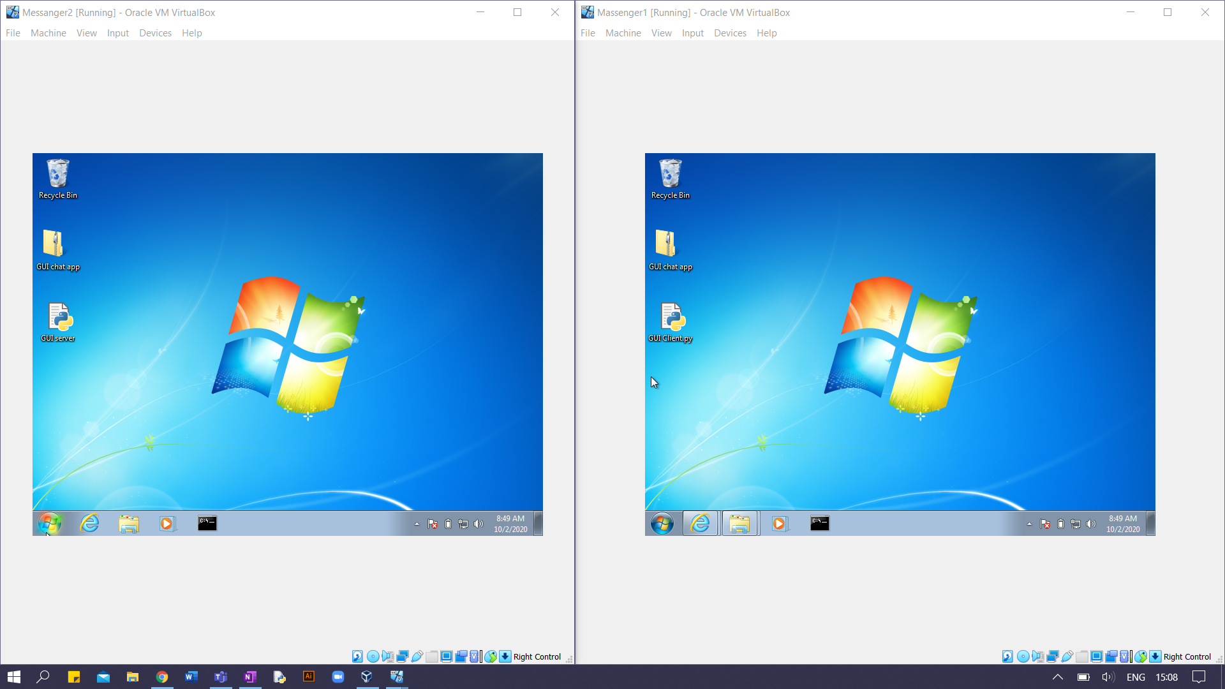Two virtual machines are shown, one of them is the server side and the other is the client side.

Server Side Client side

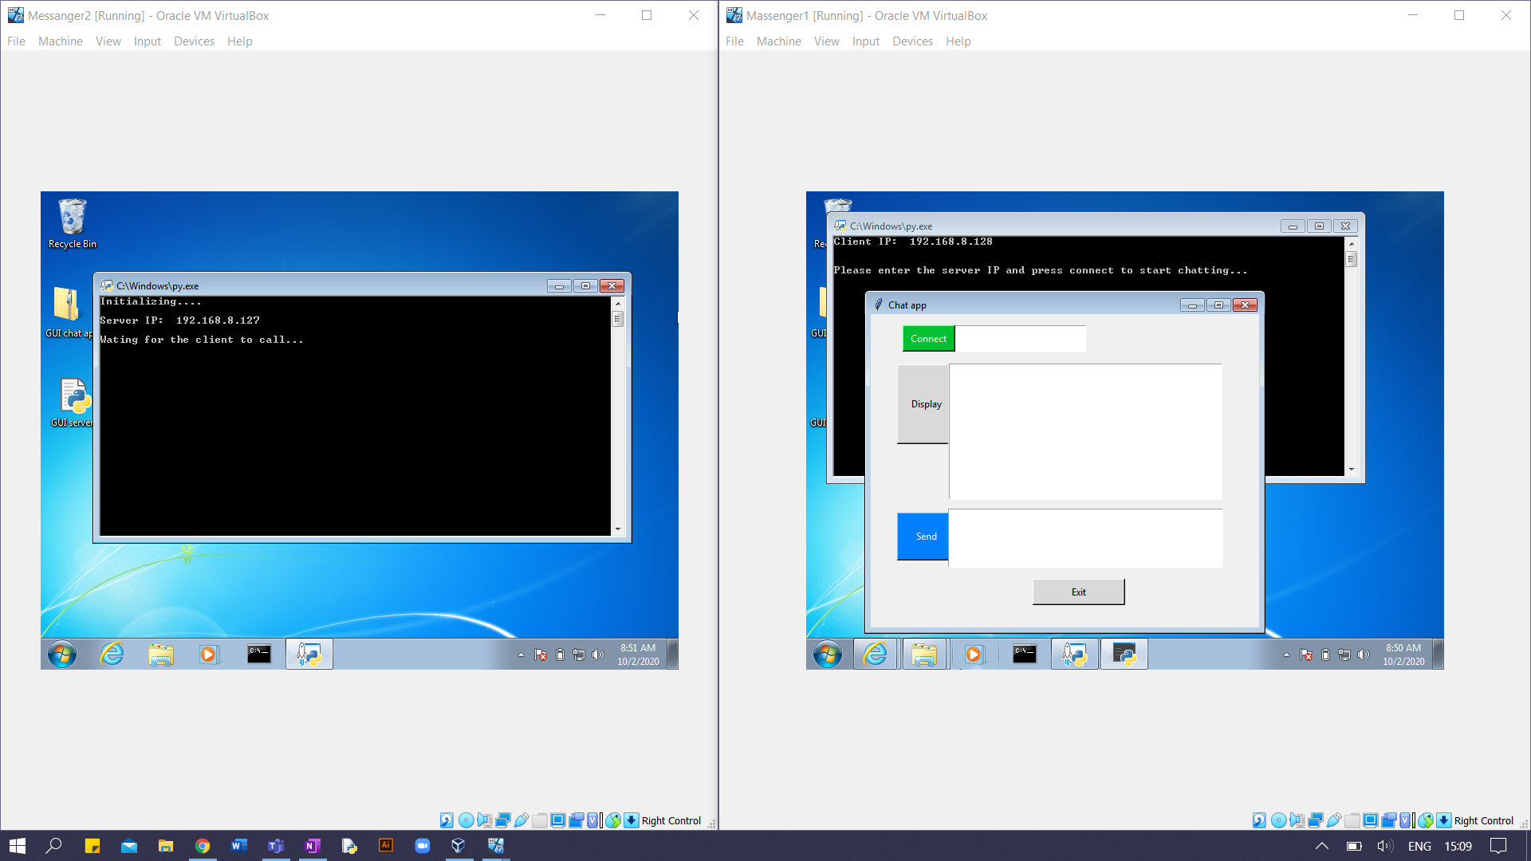

* In case to connect the client to the server, both server and client must be running.
* When we run the server, three messages will be shown in the CLI including its IP address.
* When we run the client side , a GUI chat app will be shown and two messages in the CLI including its IP address.

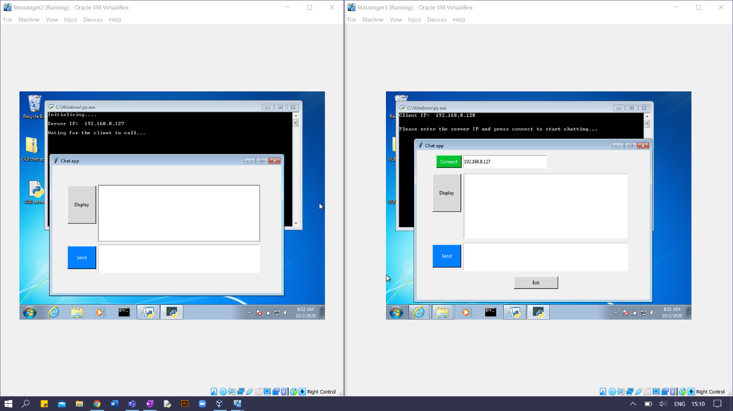

* The client enters the server IP address and click connect, then a GUI chat app will be shown in the server side.

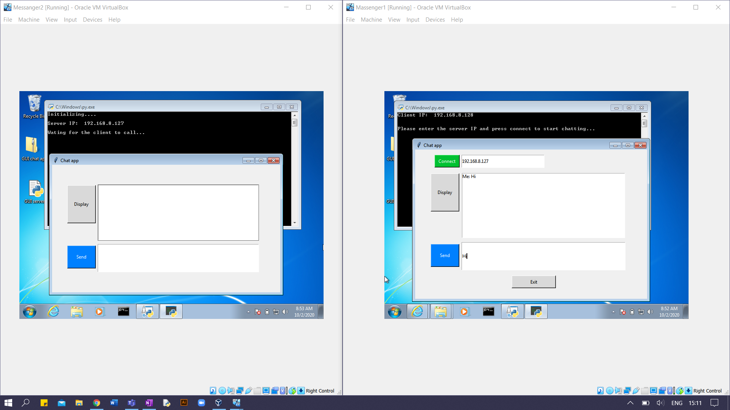

* Any of the sides can establish the chat, in this case we started with the client side, we write ‘Hi’ and press Send
* The other side has received the ‘Hi’ message but it won’t be shown unless the server press Display.

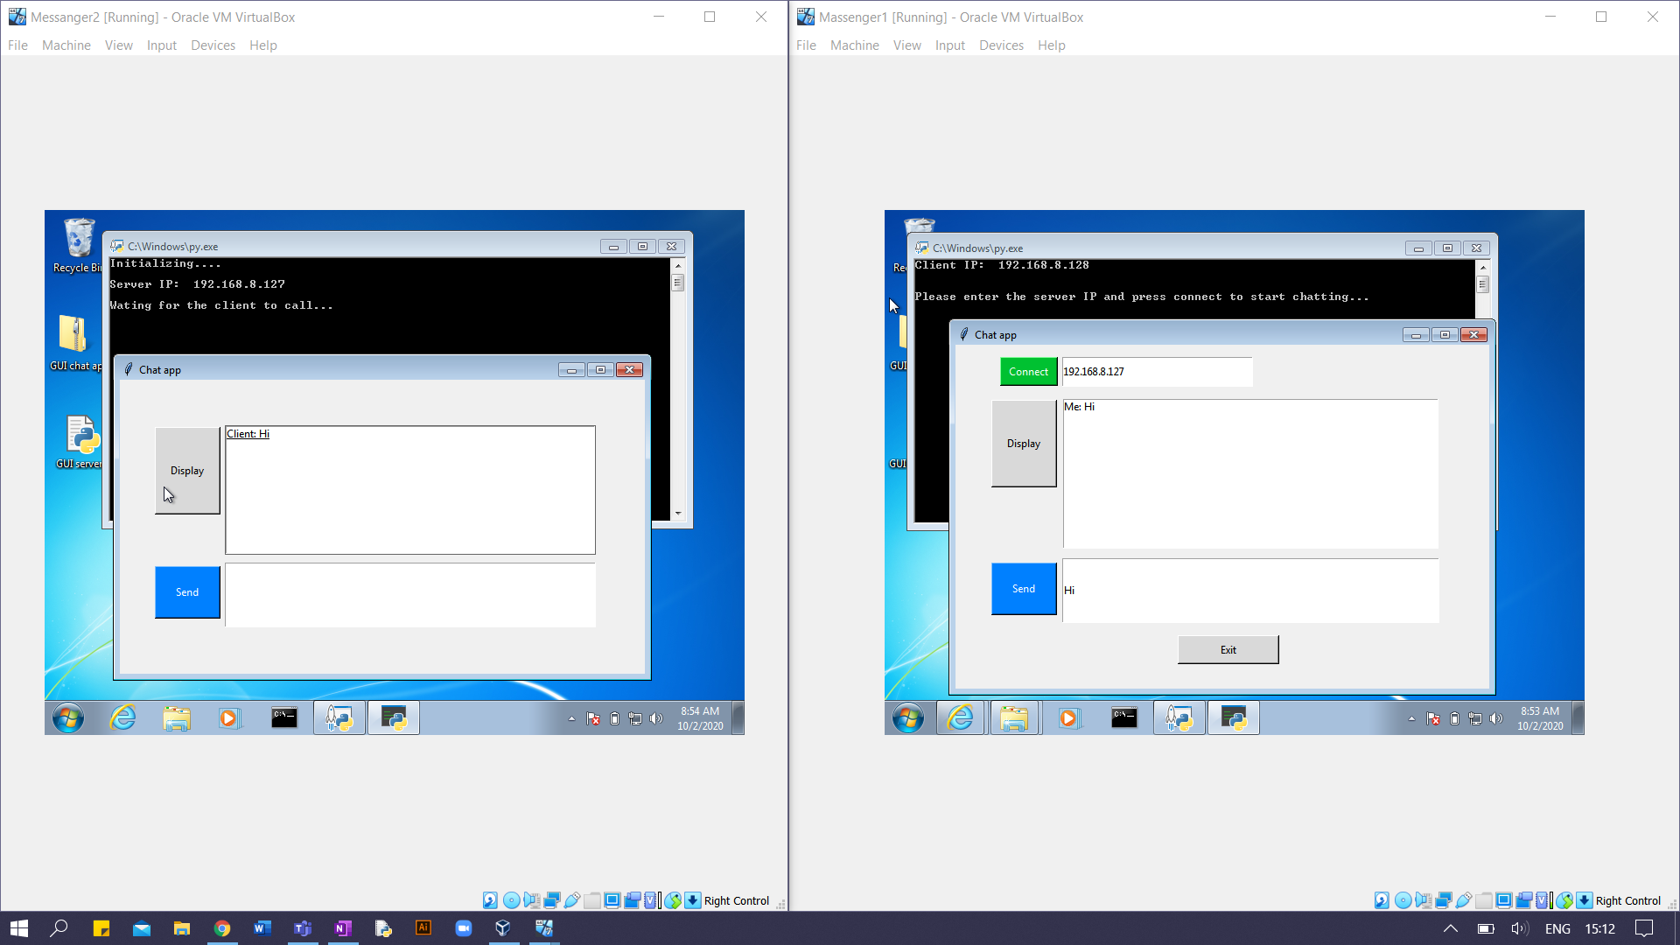

* When the server side pressed Display, the client message was shown.

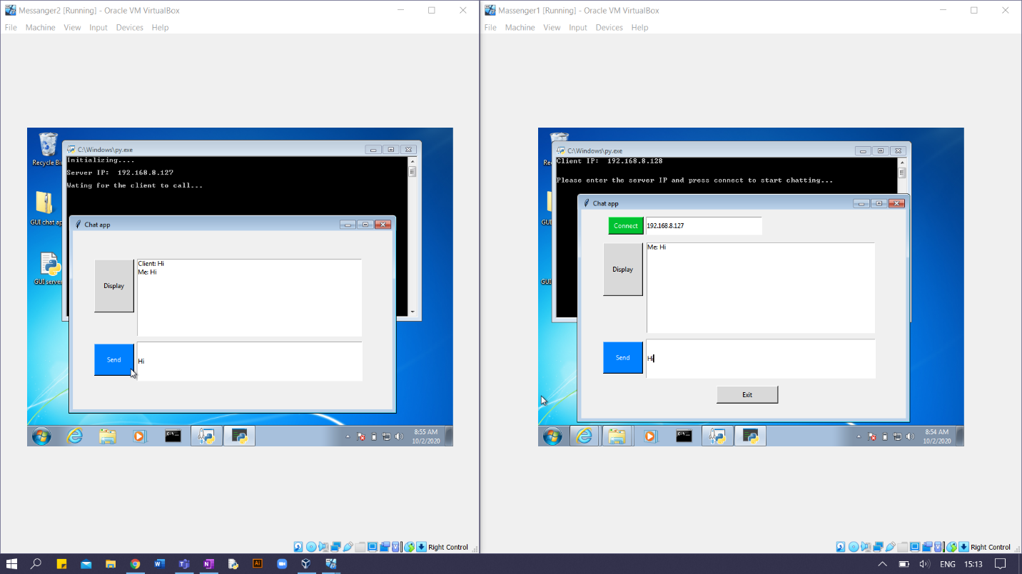

* Then the server typed ‘Hi’ and sent it, but it won’t be shown at the client side unless he press Display button.

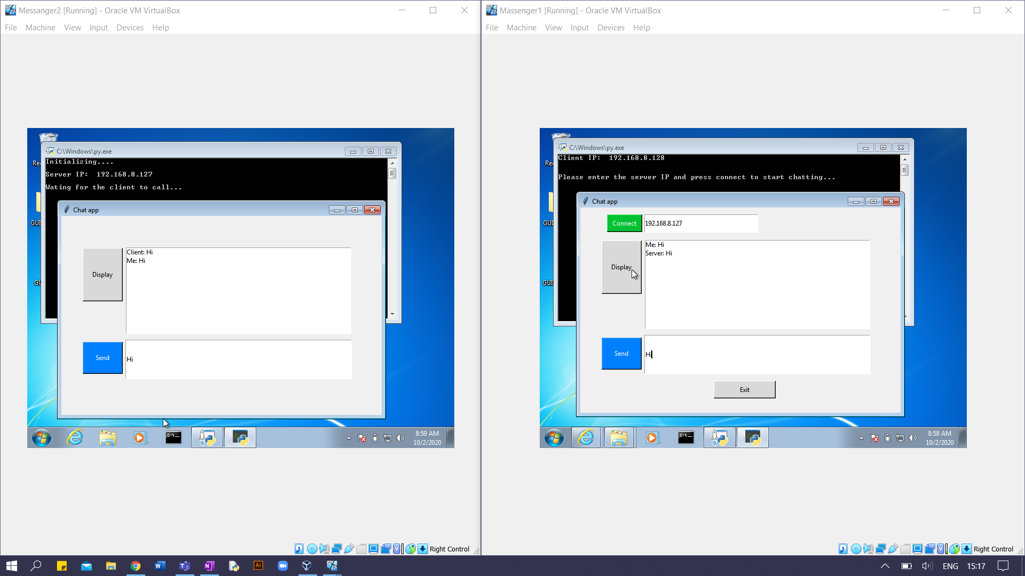

* When the client side pressed Display, the server message was shown.

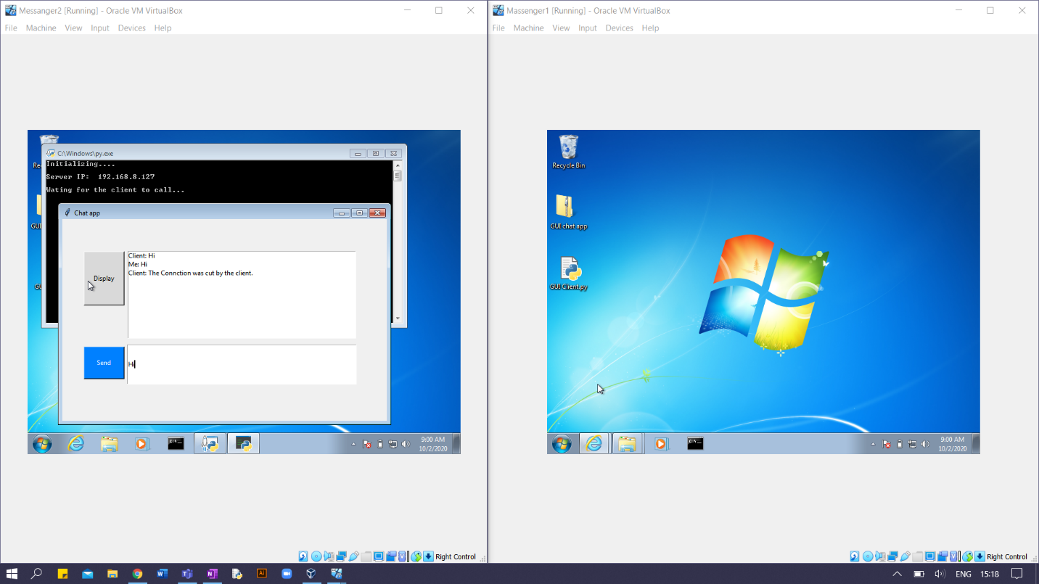

* When client presses Exit button, the client program will be closed, and a message by the client will be sent to the server indicating that the client has cut the connection.
* The message will be shown at the server when the Display button is pressed.